CONCERT @ Palazzo Contarini Polignac 19 August at 7pm

KARAVAN presents

Title of the concert : Bach Reimagined: A Dialogue Between Worlds
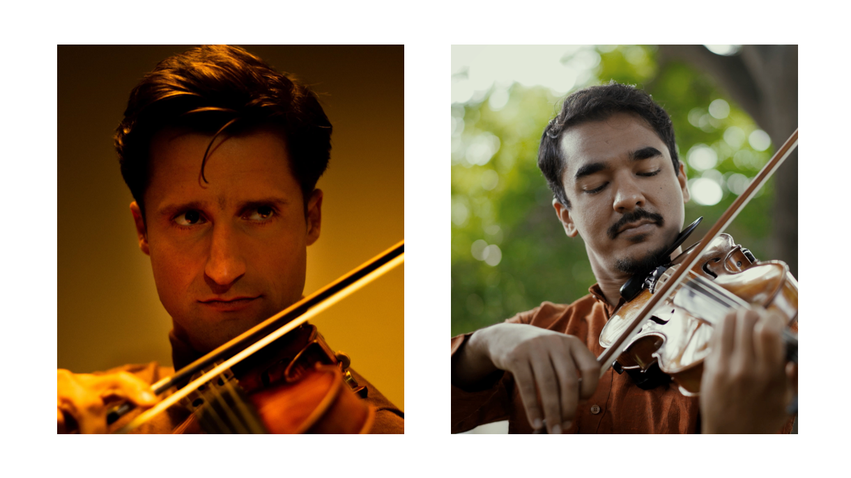
At the crossroads of two profound musical traditions, Bach Reimagined invites listeners on a journey where the introspective depth of Western classical music meets the vibrant, improvisational spirit of South Indian Carnatic music.

Centered on J.S. Bach’s iconic Partita No. 2 in D minor (BWV 1004), this performance becomes a living conversation between two violinists — Ambi Subramaniam and Lorenzo Gatto — each bringing their own language, lineage, and intuition.

Joined by the ensemble KARAVAN and percussionist Simon Leleux, the music becomes a meeting ground where baroque form engages with raga-based improvisation, and Bach’s voice reveals unexpected nuances.

Rather than blending styles, this concert opens a space for dialogue — a musical exchange shaped by listening, contrast, and connection across cultures.

(Length around 45 min)

Karavan’s Musical Journey

KARAVAN isn’t so much an orchestra as it is a collective of curious, traveling musicians who draw inspiration from encounters along the way to enrich their musical journey.
Instead of following the traditional model of CDs, albums, and tours, Karavan works around the idea of a *Logbook* — an ever-evolving record of their creative path.
This approach gives the Ensemble the freedom to keep its repertoire, its thinking, and its way of making music fluid and alive. It allows space for the human element, for spontaneity, rather than rigid rules or fixed destinations.

**It’s not about *where* we’re going — but *how* we get there**.

The Karavan Ensemble

Lorenzo Gatto, violin & direction
Julia Kotarba, cello
Natalia Kotarba, violin
Mikko Pablo, cello
Anouchka Scaillet, violin
Diede Verpoest, viola

Biographies

Lorenzo Gatto

Lorenzo Gatto studied violin under the guidance of Dirk van de Moortel, Véronique Bogaerts at the Royal Conservatory of Brussels, Herman Krebbers in the Netherlands, Augustin Dumay at the Queen Elisabeth Music Chapel, and later Boris Kuschnir in Vienna. In 2009, he earned both the Second Prize and the Audience Prize at the prestigious Queen Elisabeth Competition. The following year, after being named a “Rising Star,” he appeared in recital at some of Europe’s most renowned concert halls, including the Amsterdam Concertgebouw, the Vienna Musikverein, and the Cité de la Musique in Paris.

His career has included collaborations with distinguished conductors such as Philippe Herreweghe, Vladimir Spivakov, Walter Weller, Jan Willem de Vriend, Jaap van Zweden, Martin Sieghart, and Yannick Nézet-Séguin. As a chamber musician, he has shared the stage with leading artists including Maria João Pires, Mischa Maisky, and Martha Argerich.
Since 2015, he has performed regularly with pianist Julien Libeer. Their recording of Beethoven’s complete violin sonatas received high critical acclaim, winning a Diapason d’Or award. He performs on the 1698 “Joachim” Stradivarius.

Ambi Subramaniam

Hailed as "the new king of Indian classical violin" and “India’s Itzhak Pearlmann," Ambi Subramaniam has been trained by his father and guru, Dr. L. Subramaniam, since he was three years old and gave his first stage performance at the age of seven. He has performed across the world and was named among GQ's 25 Most Influential Young Indians in 2021.

Along with his sister Bindu, Ambi runs SaPa, which teaches music to over 40,000 children. He has co-authored over 30 textbooks, including India’s first series of textbooks dedicated to teaching the Carnatic violin.

He is a youth delegate at the United Nations for the Sri Chinmoy Peace Meditation group.
Ambi has a Ph.D. in developing a global violin technique (2020), an MPhil in Music (2014), an MBA in Finance (2012), and an LTCL in the western violin from the Trinity College of Music.

Simon Leleux

Belgian percussionist, composer, and artistic director Simon Leleux is recognized for his mastery of Arab and Middle Eastern percussion instruments, particularly the doholla and darbuka. After training with renowned masters including Ahmet Misirli, Zohar Fresco, Pedram Khavarzamini, Madjid Khaladj, Pandit Sanju Sahai, Niti Ranjan Biswas, Azzedine Jazouli, and Levent Yildirim — who broke new ground with the doholla — he developed a unique, melodic approach to the instrument that highlights its soloistic potential.

A founding member of the ensembles Spëcht and Auster Loo, Simon has also collaborated with acclaimed artists such as Fabrizio Cassol, Kudsi Erguner, Ibrahim Maalouf, Ross Daly, and Ghalia Benali. Alongside his performing career, he teaches at MuziekPublique in Brussels and at the Royal Conservatory of Brussels, drawing on his pedagogical training from the Namur Conservatory and his Master’s in Turkish percussion from Codarts, Rotterdam.

